**Ashish_RQuiz 4**

1. Ruby Program that prints the Time in different time zones

Ans :

require 'Time'

now = Time.now

puts now = now.gmtime

puts now = now.localtime

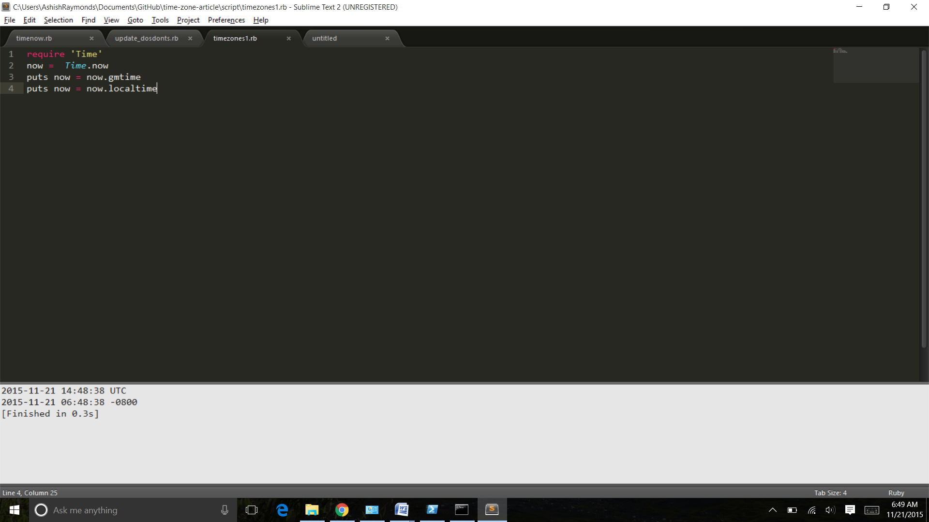

2. Write a program that iterates over an array and builds a new array that is the result of incrementing each value in the original array by a value of 2. You should have two arrays at the end of this program,

The original array and the new array you've created.Print both arrays to the screen using the p method instead of puts.

Ans:

a = [1,2,3,4,5]

b = a.collect{|x| 2+x}

p a,b

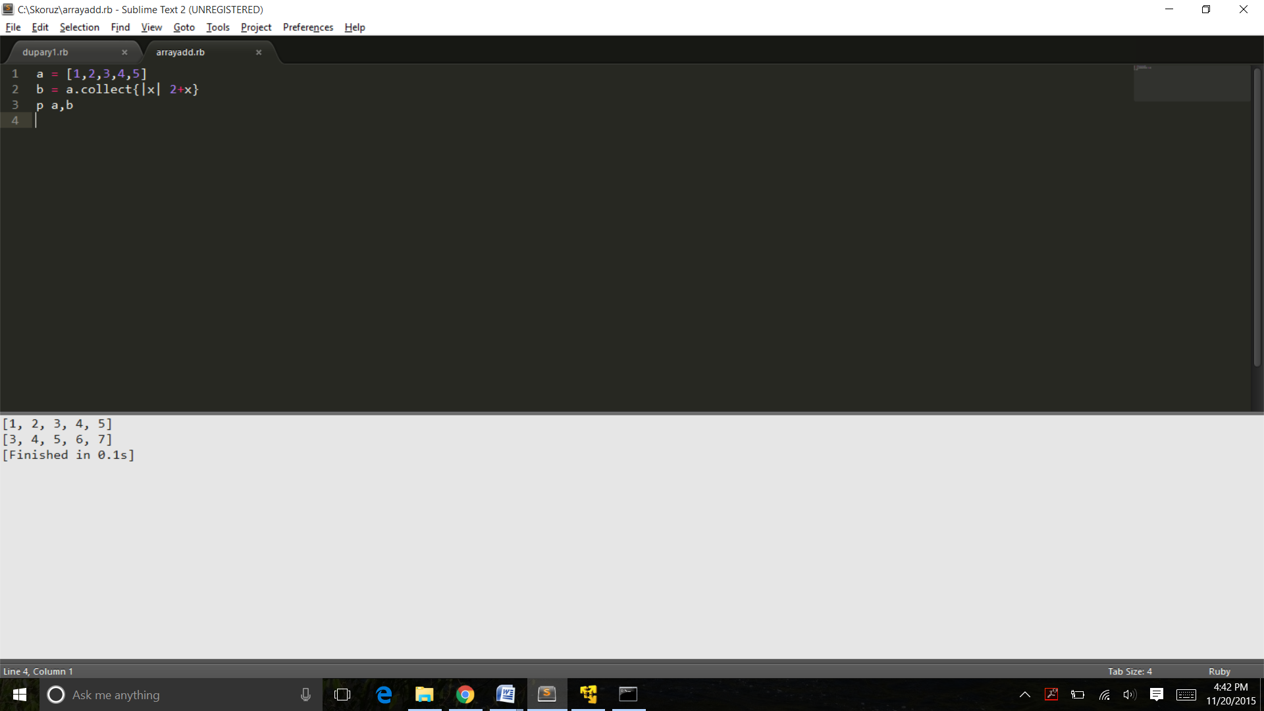

3. Ruby program to find the leap year when start and end year are given.

Ans: puts "Enter starting year:"

starting_year = gets.chomp.to_i

puts "Enter ending year:"

ending_year = gets.chomp.to_i

year = starting_year

while true

if year%4==0

if year%100!=0 || year%400 ==0

puts year.to_s + ' is a Leap Year'

end

end

year = year +1

break if year >= ending_year

end

gets

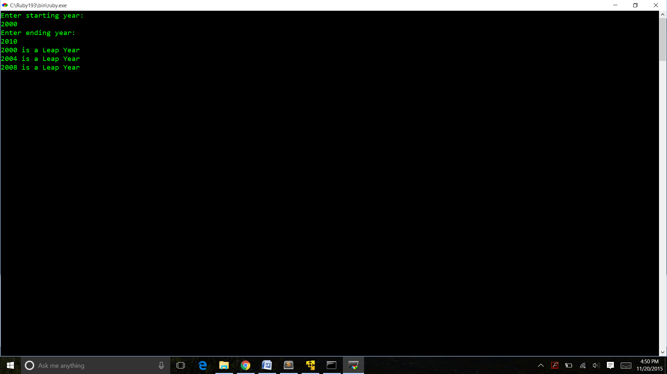

4. Ruby program that takes a numerical value and give the output as Roman number

Ans:

RomanNo = Hash[ 1000 => "M", 900 => "CM", 500 => "D", 400 => "CD", 100 => "C", 90 => "XC", 50 => "L", 40 => "XL", 10 => "X", 9 => "IX", 5 => "V", 4 => "IV", 1 => "I"]

print "Enter the number:"

num = gets.to_i

if num < 1000

RomanNo.keys.sort{|a,b| b <=> a }.each do

|n|

while num >= n

num = num-n

print RomanNo[n]

end

end

else

puts "Please enter the number below 999"

end

gets

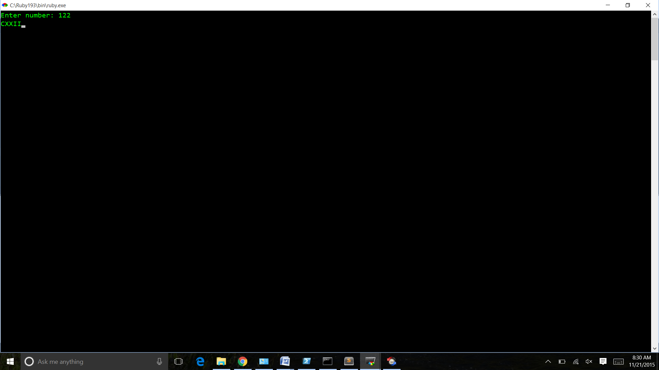

5. Write a your own ruby program that uses a Queue

Ans :

arr =["ab","bc","cd"]

print arr.unshift("yz ")

puts "\nSize of the Queue is:" ,arr.size

print "\nDeleting values:",[arr.pop]

puts "\nSize of the Queue is: " ,arr.size

print "\nInserting Values:",arr.push("xy")

puts "\nSize of the Queue is: " ,arr.size

gets

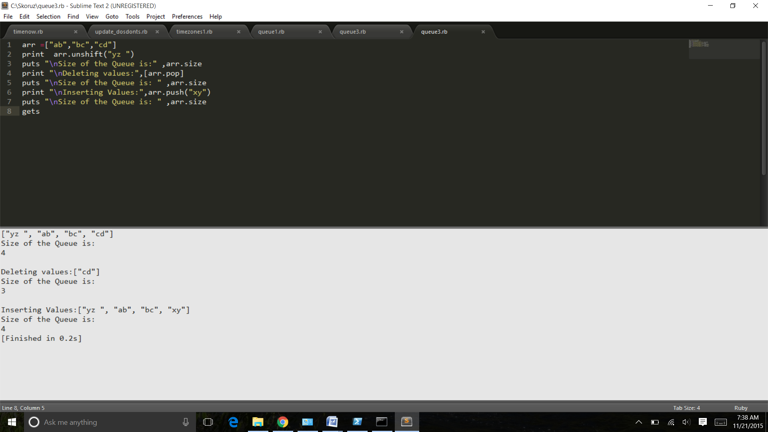

6. Write your own ruby program that uses each_ with_ index method to iterate through an array that prints each index and value

Ans:

array = ["A", "B", "C"]

array.each_with_index {|val, index| puts "#{val} => #{index}" }

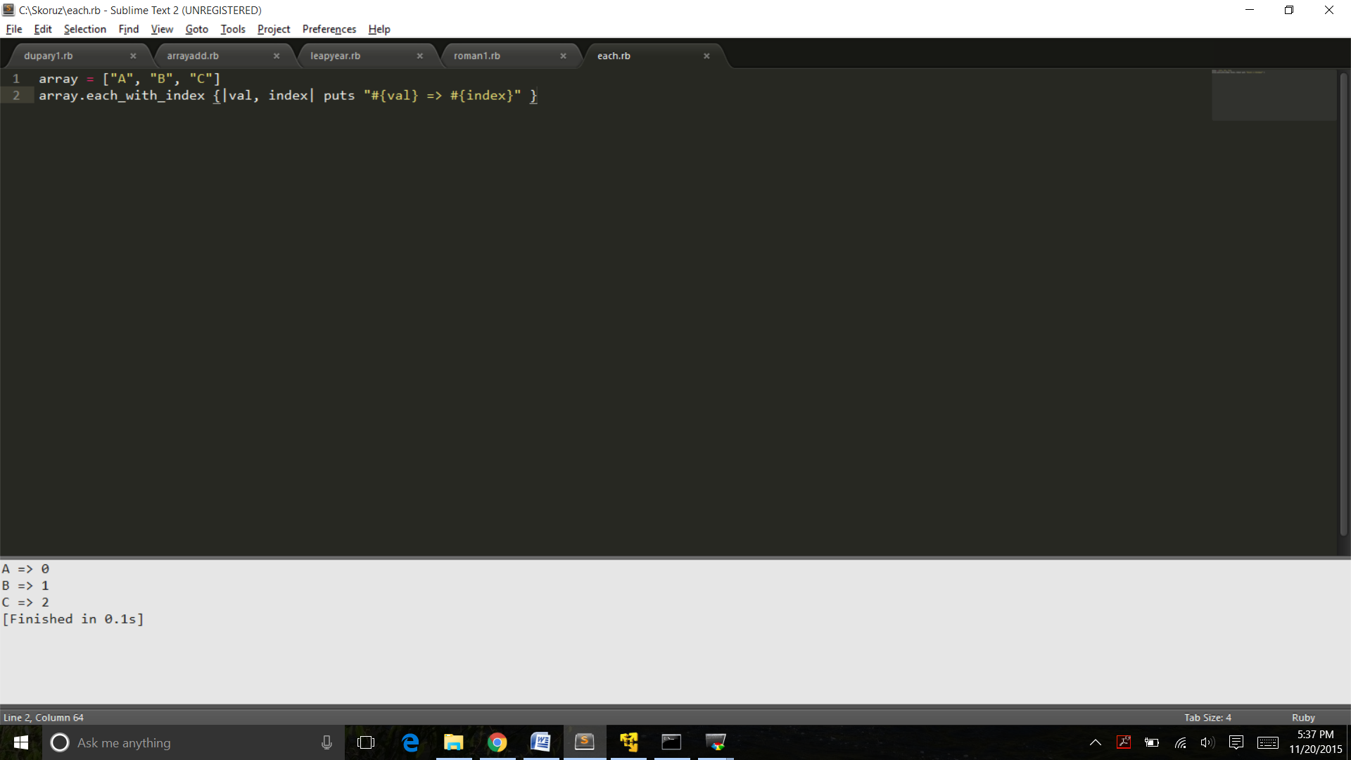

7. Ruby Program that prints if duplicates existing in a array

Ans:

array = [1, 2, 1, 3, 5, 4, 5, 5]

dup = array.select{|element| array.count(element) > 1 }

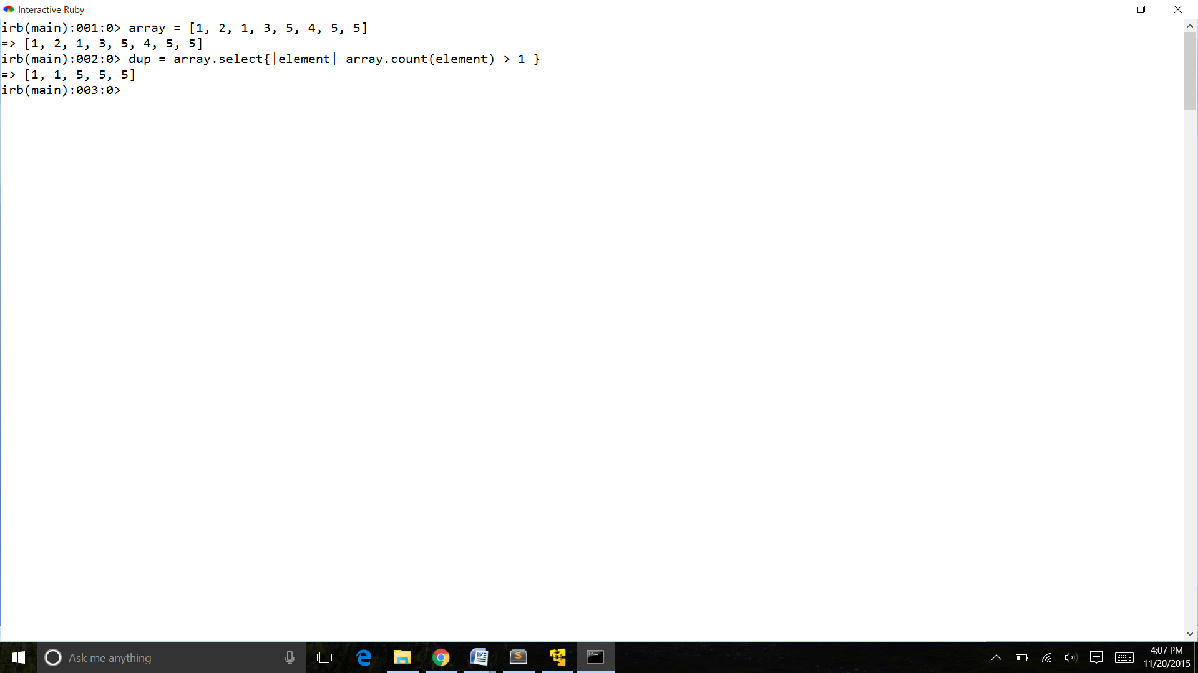

8. Write a Ruby program that prints pascal triangle

Ans: def pascal(n)

raise ArgumentError, "must be positive." if n < 1

yield ar = [1]

(n-1).times do

ar.unshift(0).push(0) # tack a zero on both ends

yield ar = ar.each_cons(2).map{|a, b| a + b }

end

end

pascal(8){|row| puts row.join(" ").center(20)}

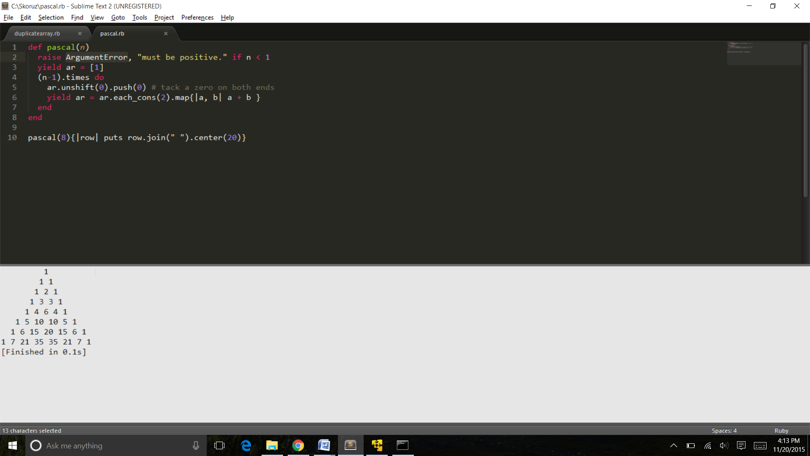

9. Write a Ruby program that prints the length of the common string when two strings are compared.

Ans:

puts "Enter the Name1"

str1 = gets.chomp

puts "Enter the Name2"

str2 = gets.chomp

if str1 === str2

puts "Length of common string",str1.length

else

puts "please Enter the same string"

end

gets

